AI HR Automation SaaS – Full System Blueprint
- Your Blueprint Now Includes:
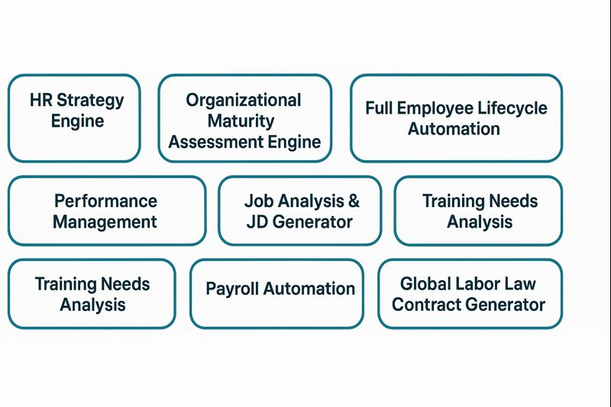
- Platform Overview
A cloud-based, multi-tenant SaaS platform that automates all major HR functions end-to-end using AI, workflow engines, and compliance modules.
The system is designed to plug into any existing HRIS/ERP or operate as a stand-alone HR platform.
Core Pillars
- AI Strategy Engine – Generates HR strategies aligned with business goals and market trends. A
- Organizational Maturity Assessment – Create questioner and analyze its result. A
- AI Job Architecture Engine – Builds job descriptions from job analysis questionnaires. A
- Lifecycle Automation Engine – Automates preboarding → onboarding → development → offboarding. A
- AI Talent Engine – Manages recruitment, mobility, promotion, and succession planning. A
- AI Performance Engine – Creates KPI frameworks, BSC models, and performance cycles. A
- Training Needs Engine – Runs TNA based on appraisal & manager inputs. B
- Payroll Engine – Computes payroll with all salary effects, deductions, and global rules. B
- Global Labor Law Engine – Drafts contracts compliant with any country. B
End-to-End User Journey Chart (HR Lifecycle Automation)
User Experience
Step | User | System Action | Output
1. Input Org Data | HR | Upload strategy, goals, structure | Database initialized
2. Maturity Assessment | Employees, HR | Fill survey | Maturity Score
3. HR Strategy Generation | HR | AI creates strategy | HR Roadmap
4. JD Creation | Managers | Fill job analysis | JD Generated
5. Recruitment | Recruiter | Post → Screen → Select | Candidate selected
6. Onboarding | HR | Automated workflow | Checklist completed
7. Performance Cycle | Managers/Employees | KPIs → Reviews | Final rating
8. TNA Process | HR | Auto-analyzed gaps | Training Plan
9. Payroll | Payroll team | Auto-calculation | Payslips
10. Contract Creation | HR | Select country → AI generates | Legal contract

- Components:

1. AI HR STRATEGY ENGINE
Generates a dynamic HR strategy based on macro, micro, and organizational objectives.
Inputs
- Company strategic goals
- Workforce analytics
- Market data (PESTEL, labor market, industry trends)
- Organizational maturity level (from Module 2)
AI Processing
- LLM → Strategy narrative
- ML → Workforce forecasting
- Rules Engine → HR priorities mapping
Outputs
- HR strategic pillars (People, Culture, Talent, Performance, Rewards)
- 12–24 month roadmap
- Strategic KPIs for HR
- Budget estimation

2. ORGANIZATIONAL MATURITY ASSESSMENT ENGINE
Evaluates the organization’s readiness across HR, leadership, culture, operations, and technology.
Framework
- Five domains: HR, Leadership, Culture, Operations, Digital/AI Readiness
- Five-level maturity scale (Initial → Optimized)
Inputs
- Multi-user questionnaires (HR, managers, employees)
- Existing systems, processes, KPIs, policies
AI Processing
- LLM → Converts qualitative answers into maturity scores
- ML → Benchmark comparison
- Rules Engine → Consistency validation
Outputs
- Maturity level (1–5)
- Heatmaps, dashboards
- Gap analysis
- 12-month recommended actions
- Automatically feeds into HR Strategy module

3. PREBOARDING, ONBOARDING & OFFBOARDING AUTOMATION
End-to-end lifecycle workflows for new hires and leavers.
Processes Automated
- Document collection
- Contract issuance
- IT provisioning requests
- Orientation plan
- Probation evaluation workflow
- Exit interviews
- Final settlement workflow
AI Functions
- Generate welcome emails
- Create onboarding plans
- Summarize exit interviews
- Predict onboarding success risk
System Features
- Configurable checklists
- Role-based workflows
- Alerts & notifications
- Integration with IT/Facilities systems

4. RECRUITMENT, MOBILITY, SUCCESSION & PROMOTION ENGINE
Recruitment Features
- AI job posting generator
- AI CV parser & ranking
- AI interview question generator
- Candidate scoring (skills, experience, cultural fit)
- Offer letter automation
Internal Mobility
- Employee career path recommendations
- Open roles match engine
- Skill-gap detection
Succession Planning
- Talent matrix (9-box)
- Successor readiness scoring
- Risk of loss prediction
Promotion Engine
- Evidence-based scoring (KPI, skills, tenure, performance)
- AI-generated promotion recommendation summary

5. PERFORMANCE MANAGEMENT ENGINE
Builds performance framework, KPIs, and evaluation cycles.
Capabilities
- Define performance strategy (OKR, KPI, BSC, hybrid)
- Cascading goals (corporate → department → individual)
- KPI library + AI-generated KPIs
- Balanced Scorecard builder
- Competency assessment
AI Processing
- Create KPIs based on strategy, JD, and industry
- Detect rating bias
- Suggest calibration adjustments
- Generate manager comments
Outputs
- Individual scorecards
- Performance analytics
- Calibration report

6. AI JOB DESCRIPTION (JD) GENERATOR
Creates accurate, industry-specific JDs using job analysis questionnaires.
Inputs
- Job analysis form completed by manager or employee:
  - Duties, tasks, skills, tools, conditions
  - Competencies
  - Reporting structure
AI Processing
- LLM → Converts raw inputs into structured JD
- Benchmarking against global job libraries (O*NET, ESCO)
- Validation rules for accuracy
Outputs
- Job Purpose
- Duties & Responsibilities
- Skills (Technical & Behavioral)
- Competency Model
- KPIs
- Qualifications
Formats: Short/Long/ATS-friendly/Competency-based

7. TRAINING NEEDS ANALYSIS (TNA) ENGINE
Automated learning needs discovery based on performance and manager inputs.
Inputs
- Performance appraisal scores
- Competency gaps
- TNA questionnaire from managers
- JD competency model
Processing
- ML → Skill gap detection
- LLM → Interprets qualitative manager inputs
- Rules Engine → Priority ranking
Outputs
- TNA Report
- Learning priority map (Mandatory / Strategic / Optional)
- Learning curriculum recommendations
- Training ROI estimator
- Automatic creation of development plans

8. PAYROLL AUTOMATION ENGINE
Handles global payroll calculations with all salary effects.
Core Functions
- Salary structure builder
- Allowances, deductions, overtime, bonuses
- Leave impact on pay
- Loan/advance management
- End-of-service benefits
- Tax rules (country-specific)
AI Functions
- Payroll anomaly detection
- Salary prediction modeling
- Financial compliance alerts
System Outputs
- Payroll slips
- Government tax files
- Accounting journal entries
- Bank transfer file (ISO 20022 or text formats)

9. GLOBAL LABOR LAW CONTRACT GENERATOR
Generates fully compliant contracts for any country.
Inputs
- Country & jurisdiction
- Role + JD
- Salary structure
- Contract type (limited, unlimited, part-time, remote)
Processing
- RAG (retrieval-augmented generation) with legal datasets
- Hard-coded compliance rules (probation, notice period, working hours)
Outputs
- Legally compliant employment contract
- Optional annexes:
  - Job description
  - KPI sheet
  - Confidentiality & IP clauses
  - Remote work policy

- CROSS-PLATFORM FEATURES

Role-Based Access Control
- Admin
- HR
- Manager
- Employee
- Auditor
Document Engine
- Policy builder
- Version control
- Template customization
- E-signature
Workforce Analytics Layer
- Attrition forecasting
- Engagement predictions
- Recruitment funnel analytics
- Headcount & workforce planning
API Layer
- REST + Webhooks
- Integrations for ERP/Payroll/ATS

- SUGGESTED BUILD SEQUENCE (ROADMAP)

PHASE 1 – Foundation
- HR Strategy Engine
- JD Generator
- Recruitment Module
- Onboarding Automation
PHASE 2 – Core HR
- Performance Management
- TNA Engine
- Payroll Engine
PHASE 3 – Advanced AI & Global
- Global Labor Law Engine
- Succession Planning
- Organizational Maturity Assessment
- Workforce Analytics & Predictive Models

